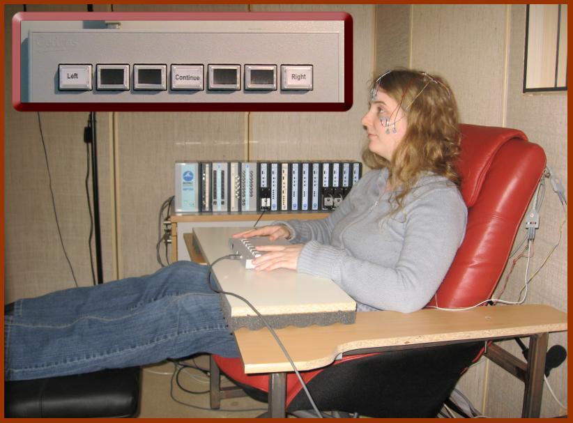

Facial activity is recorded using electromyography (EMG) while participant is watching emotional video clips. Inset shows the response box used to collect the responses of the participant. The experiment takes place in a sound-isolated box. Films are projected through a window from the neighboring control room.

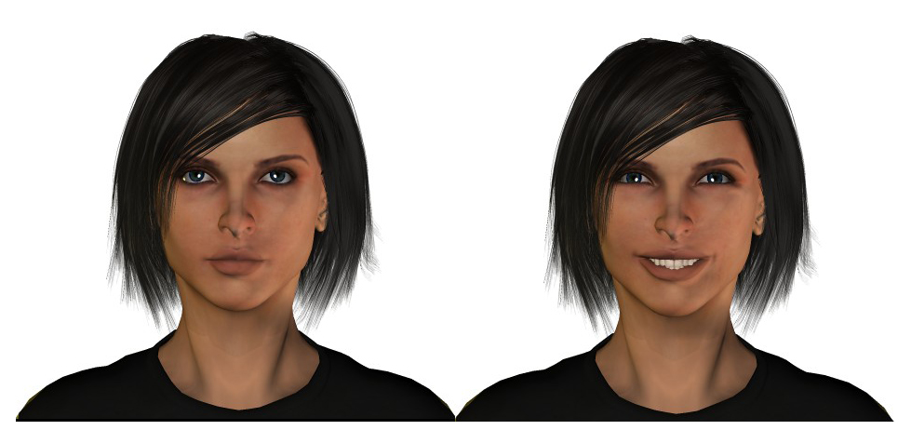

These faces were created using POSER 6 software (e frontier) and are used to study, for example, the role of temporal aspects of facial displays in person and expression perception.

